Step 1
Classification #1
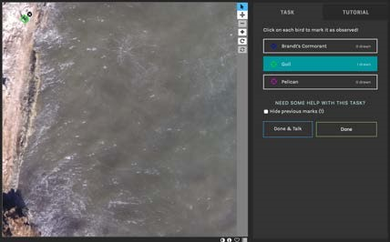
1 Gull

Classification #2
88 Brandt’s Cormorant
1 Gull

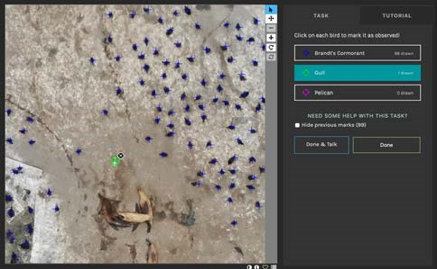

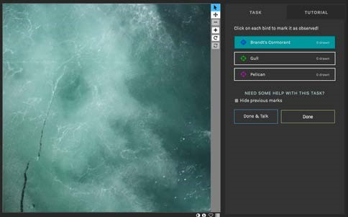
Classification #3
0 Features

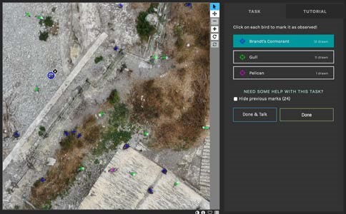
Classification #4
12 Brandt’s Cormorant
11 Gull
1 Pelican

Classification #5

0 Features
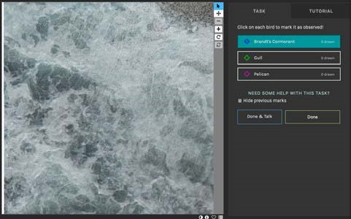

Classification #6

15 Brandt’s Cormorant
38 Gull
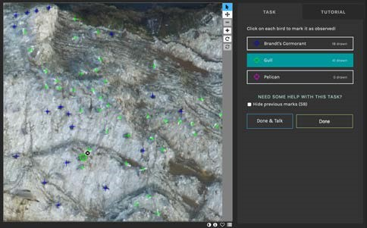

Classification #7


0 Features

Classification #8


0 Features

Classification #9
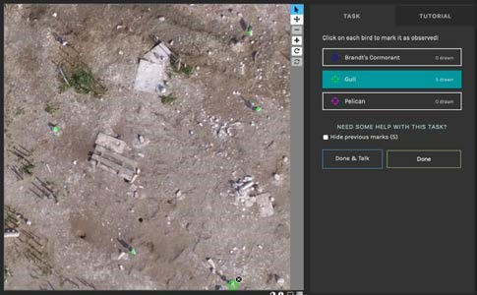

5 Gulls

Classification #10
1 Gull
10 Pelican
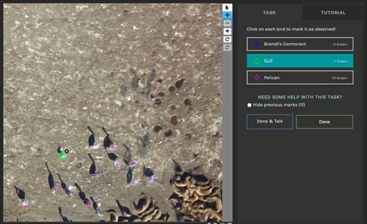
[EQR Rubric/Representation; EQR Rubric/Calculation or Transformation]
Step 2
 | Brandt’s Cormorants | Gulls | Pelicans
Classification #1 | 0 | 1 | 0
Classification #2 | 88 | 1 | 0
Classification #3 | 0 | 0 | 0
Classification #4 | 12 | 11 | 1
Classification #5 | 0 | 0 | 0
Classification #6 | 15 | 38 | o
Classification #7 | 0 | 0 | 0
Classification #8 | 0 | 0 | 0
Classification #9 | 0 | 5 | 0
Classification #10 | 0 | 1 | 10
Totals | 115 | 57 | 11
[EQR Rubric/Representation; EQR Rubric/Calculation or Transformation]

Step 3
 | Brandt’s Cormorants | Gulls | Pelicans
Minimum # | 0 | 0 | 0
Maximum # | 88 | 38 | 10
Range(Max-Min) | 88 | 38 | 10
Average | 11.5 | 5.7 | 1.1
[EQR Rubric/Representation; EQR Rubric/Calculation or Transformation]

Step 4

Step 5. Preceding Questions
- In 250 words or more, give a background of the Zooniverse project that you worked on. Write this description like you are talking to a friend: someone who may not know that much about science. Use words that are familiar to you—use your own words. Explain the title of the project, the purpose, and the different features that you encountered. Explain what each feature is and
how you identify it. State the importance of each feature. [CT Rubric/Explanation of Issues; WVC
Rubric/Context of and Purpose for Writing] [xxx words]

Type your minimum 250 word response here.
Earth science is the scientific study of earth’s structure, processes and properties. Deeper understanding of this phenomena is very vital to maintain and sustain life on the planet. Sustaining the existence of Brandt’s cormorants, gulls and pelicans needs scientific understanding knowledge of the natural materials and processes connected to the geosphere, hydrosphere, atmosphere and biosphere.
Different images for classification have been taken randomly from various places in order to understand distribution of features in relation to locality. Features encountered were Brandt’s cormorants, gulls and pelicans.
“Brandt’s cormorant is mostly a marine bird of the cormorant family of seabirds that inhabits the Pacific Coast of North America. Has white plumes on its neck and back mostly during the early breeding stage”, According to Wikipedia. Their diet consists of mainly fish. They dive beneath the sea surface in order to catch their prey. Brandt’s cormorant are identified using the key color which is blue as shown in classification #2. Their ecological benefits is that their eggs can be consumed by birds of prey and reptiles.

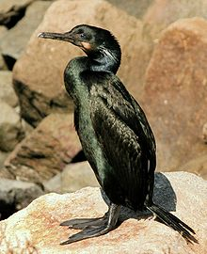

Gulls are also seabirds that belong to Laridae. Their size ranges from medium to large and color pattern is grey or white mostly with black markings on the wings or head. Their feets are webbed, long bills and are stout. Their nests are grounded. Gulls are omnivorous which feed on a wide range of prey. They feed on both live and dead food such as fish, molluscs, crustaceans, some grains and small birds. They spend most of their life around the sea since their main food sources they do obtain from the sea. Gulls are identified using the key color which is green as shown in classification #6. The importance of gulls is that they are bioindicators, reservoirs and vectors. Being scavengers plays a big role in cleaning environment preventin bad smell from clouding the atmosphere.
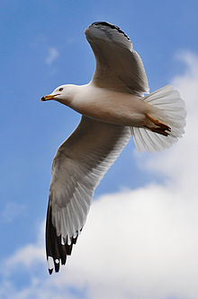
Fig1
Pelican are large birds with long bills, long neck and webbed feet. They have short tail and square in shape. Their wings are long and broad for soaring and flying higher. The plumage for pelicans are light-coloured. Pelicans do inhabit warm regions. They are motly carnivoresv feeding on flesh such as amphibians, insects and crustaceans. Pelicans also nest in colonies. Pelicans are identified using the key color which is purple as shown in classification #10. Pelicans play a vital ecological role in food chains in that they do consume fish and invertebrates. Their eggs can also be consumed by birds of prey and reptiles.

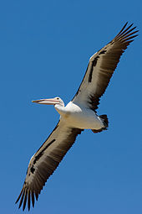
- Explain, in depth, what you, as a Zooniverse Expert, see in Classification #4 (Step 1). Again, pretend like you are explaining this classification—and how you classified it—to a friend who is unfamiliar with this project. How did you know how to classify each feature? Your response should be at least 150 words. [WVC Rubric/Content Development] [xxx words
In classification 4, at least each feature was represented. There are 12 Brandt’s cormorants, 11gulls and 1 pelican. This means there was a conducive environment that favoured the growth of those features. The following are some the conditions that led to the increase in number for the Brandit’s Cormorants existence than the rest that is gulls and pelicans. Presence of favarouble climatic patterns that supports the growth of their food, proximity to the ocean or sea where they can obtain their food easily and they have good natural selection in relation to gulls and pelicans. Classification was based on the following methodology. The screenshot had some images which were marked by different colors shown in the key. For instance, Brandt’s cormorants was identified using the blue color, the gulls were identified using the green color and the pelican was identified using the purple color. This was the key pillar that was tremendous which aided in easy identification of every single feature that existed in classification 4.
WVC Rubric/Content Development] [166 words]

- Read your project’s “About” and “FAQ” webpages. What is the source of the images that you classified? Your response should be a minimum of 100 words. If you quote or paraphrase the
Zooniverse webpage, be sure to include a proper MLA citation. [CT Rubric/Evidence; WVC Rubric/Sources and Evidence] [xxx words]
Zooniverse project is the people-powered research project. This means that we do not need any specialized background, training, or expertise to participate in any zooniverse projects, anybody globally can take this project. Researchers make it easy for anyone to contribute to real academic research as long as you own a computer and at your convenient place and time. Researchers prepare the study by gathering authentic objects of interests such as images of faraway galaxies, historical records, and diaries or videos of animals in their natural habitat.
Therefore, the source of images that are classified mostly come from volunteers and researchers who have a common interest for citizen science.
(About and FQA, n.d.)
[CT Rubric/Evidence; WVC Rubric/Sources and Evidence] [108 words]

- Consider the work you did in Steps 3 and 4. What patterns emerge from this data? Explain any trends that are shown by your graph (Step 4). Your response should be at least 200 words in length. Note: you can’t write 200 words on “I don’t see a pattern.” Try to find one, even if it’s
difficult. [CT Rubric/Evidence; WVC Rubric/ Readability of Visual Elements; WVC Rubric/Relevance, Accuracy, and Integration of Visual Elements; EQR Rubric/Interpretation; EQR Rubric/Communications; EQR Appliction/Analysis] [xxx words]

Type your minimum 200 word response here.
In step 3, the following patterns can be deduced. The minimum number has a stationarity pattern. The features have constant minimum number starting all of them from zero that is Brandt’s cormorants, gulls and pelicans their minimum number starts from zero. The maximum number decreases from left to right. Even the average number of the recorded features decreases from left to right. The range pattern increases from right to left. Due to minimum number in all the features having a minimum value of zero, calculating the range was easy. Just only taking the maximum number and subtracting it from a zero by default when a number is subtracted from a zero automatically that number becomes the result.
Going back to step 4 on the graph, deducing a trend is not a rocket science since the most visible trend here can be easily identified. The trend is exponential. When you draw an imaginary line touching the edges of the bars on the graph, you will realize that the trend that is formed is a curved line that is most useful when values of data rise or fall at an increasingly steady fast rate. This phenomena is a trend known as exponential trend.
[CT Rubric/Evidence; WVC Rubric/ Readability of Visual Elements; WVC Rubric/Relevance, Accuracy, and Integration of Visual Elements; EQR Rubric/Interpretation; EQR Rubric/Communications; EQR Appliction/Analysis] [201 words]

- Can you offer any possible explanations for the patterns that you observe? Include any numerical support for your explanation. Your response should be at least 200 words long. Your explanation does not have to be correct—write down any plausible explanations (hypotheses)
you can think of. [CT Rubric/Evidence; WVC Rubric/ Readability of Visual Elements; WVC Rubric/Relevance, Accuracy, and Integration of Visual Elements; EQR thRubric/Interpretation; EQR Rubric/Communications; EQR Application/Analysis] [xxx words]

Type your minimum 200 word response here.
The minimum number has a stationarity pattern. This means that a stationery time series is one in which the properties for statistical whereby variances seems to be constant over a period of time. A stationary sequence varies within a constant or persistent mean level, which does not decrease nor increase systematically over a period of time.
The exponential trend is a methodology which makes curved lines nonlinear whereas the data falls or rises at higher rate. Brandt’s cormorants have the highest population number with an average size of 11.5 as shown on the graph in step 4 above. Gulls are the second highest in population with an average size of 5.7 and lastly the pelicans have the lowest population number with an average size of 1.1
The following are some of the possible conditions that led to the high average rate size for the Brandt’s Cormorants existence than the rest features that is gulls and pelicans. Presence of favorable climatic patterns that supports the growth of their food, proximity to the ocean or sea where they can obtain their food easily, they are omnivores thus feed on both flesh and grains which give them competitive advantage and they have good natural selection in relation to gulls and pelicans.
[CT Rubric/Evidence; WVC Rubric/ Readability of Visual Elements; WVC Rubric/Relevance, Accuracy, and Integration of Visual Elements; EQR thRubric/Interpretation; EQR Rubric/Communications; EQR Application/Analysis] [208 words]

- This project asked you to do an additional 10 classifications. If, instead, you were asked to choose your 10 favorite classifications, how would that impact the patterns that you observed in your data? Would your results be different? How? Your answer should be at least 150 words long. [CT Rubric/Influence of Context and Assumptions; EQR Rubric/Assumptions] [xxx words]

Type your minimum 150 word response here.
I hope you will ask me this question, thanks. Changing any value in a dataset affects the range of patterns in various ways. There will be a big disparity in patterns of my observed data. This patterns for instance can be much pronounced. The impact can be positive or negative. The population size of Brandt’s cormorants as depicted by the average size could be higher since in my classifications would only have included screenshots with at least having some features. The negative impact of this is that will lead to derived, cooked and biased data which will not be factual and well representing. Yes, my results could be different simply because could only include in my classification the screenshots with a high number of features. How this changes brings differences in my results is through the following way; when performing various classifications, excluding screenshots with no images or features implies that I want to only capture values which are positive integers.
[CT Rubric/Influence of Context and Assumptions; EQR Rubric/Assumptions] [161 words]

- During this project, did you encounter any classifications that were unclear photographs? What could cause the loss of data or lack of data? Can you identify any conditions that could impact the collection of data (for example: historical, ethical, political, cultural, environmental, technological, or circumstantial conditions)? Your answer should be at least 200 words long. [CT
Rubric/Influence of Context and Assumptions; EQR Rubric/Assumptions; EQR Rubric/Communications] [xxx words]

Type your minimum 200 word response here.
Some classifications had unclear photographs. Causes of data loss or lack of data is caused by various factors for instance, image file corruption. Data corruption is a common problem that attacks computers. When an image is corrupted the computer may not open. When it opens it may be blurred showing gray bars, black bars or random colors over some parts of the picture. Therefore, the computer cannot be able to read and write that image leading to unclear photographs.
Technological improvement has a major impact on data collection. Big data can now be collected, stored and analyzed since there are machines with high computational power which makes it possible to mine all sorts of data.
Ethics play a big role in data collection. Ethical standards needs to be maintained during data collection and the research plan ought to describe the steps and measures that must be taken for participants protection from exploitation. Ethics mostly dictates that data collected must be used only for the intended purpose as told to the participant.
Culture. Culture tells about the behaviors, beliefs, values, customs, traditions and symbols of a particular community. There should be cultural sensitivity which means that you are aware of a participant culture to avoid asking them questions which may invoke them.[CT
Rubric/Influence of Context and Assumptions; EQR Rubric/Assumptions; EQR Rubric/Communications] [212 words]

- In 300 words or more, and using three (3) or more credible and relevant sources (like news articles or university webpages) explain the concept and importance of “citizen science.” Your sources must be referenced in this text and below it in MLA formatting. When calculating your word count for this question, exclude any quoted material. For example, if your paragraph is 200 words long, but 50 words are quoted from an article, then you only report the 150 words that you wrote. [WVC Rubric / Sources and Evidence] [xxx words]

Type your minimum 300 word response here.
Citizen science can mean scientific research work done by the general public who volunteers to take research work by collecting data of various images and videos using their own computational devices such as phones, cameras and computers. The collected data now is uploaded into the cloud for further analysis.
Citizen science does not require any special skill for someone to take part in it. What it takes for someone to be a citizen scientist is that being passionate about your environment. This orchestrates you in exploring the state of nature.
Citizen science is categorized into projects. Everyone like to do the things they love. Putting projects into categories plays a bigger role in the sense that it enables a person to participate in a project he or she likes. The following are types of projects that exists in citizen science to mention but a few monitoring bird nests, search space, wildlife observation, bird census and bird watch.
Citizen science is an important tool as far as research is concern. It has benefits to both researchers and the society. The following are the benefits of citizen science.
Educating and infusing people about the natural world. The natural world contains various creatures such as plants, microorganisms, animals, birds generally we call them wildlife. People get to learn and appreciate this creature since some of them are so vital in the ecological system.
Citizen science improves data quality. Data quality is an aspect that needs to be observed when collecting data. Good data quality is an assurance the information got from mining and analyzing the data is of significant use for its intended purpose. This leads to good decision making.
Problem solving. There is a say that goes like, “a problem shared is half solved”, citizen science provides a common platform where a particular problem is discussed. Extensive research is done by diversified people, their findings are analyzed and comparisons are made. Findings which tend to be agreeing are circled out since it is likely to be part of the solution of the subject matter.
above
[WVC Rubric / Sources and Evidence] [342 words]

- What is the overall impact to society of your Zooniverse project? How does this project allow scientists to gain understanding of the scientific issue? Your response should be at least 200 words long. [CT Rubric/Student’s Position] [xxx words]

Type your minimum 200 word response here.
Zooniverse projects has societal impacts which ensures that the scientific approaches, methodologies and theories are aligned with the challenges the society wallow in and this triggers the society to fully participate in order to obtain a solution to the problem facing them.
In addition to that, zooniverse project is a powerful tool that brings together people across the global world coming up to participate in scientific research. This collaboration is vital since everyone feels that sense of ownership of being a participant which boosts their morale. Therefore, the society is well informed off.
The following are ways in which scientists gain understanding of the scientific issue in the zooniverse project;
Public participation allows diversification of data collection from different locations across the world which in turn provides scientists with different sources to tap data, analyze and mine. Therefore, it becomes so easy for them to make strong decision basing on the information they have which was made possible by having qualitative data. Quality assurance team must also be employed in order to ensure data collected and stored is of quality.
For instance, when in was putting data into categories, I noticed one thing, there were some photographs that had blurred images or features which was too difficult to view. This will adversely affect the preceding analysis processes.
[CT Rubric/Student’s Position] [217 words]

- Do you think that people who have not spent hours working on Zooniverse like you have would see the benefit of this project? Why or why not? Please consider other viewpoints than your own to answer this question. Your response should be at least 200 words long. [CT Rubric/Student’s Position] [xxx words]

Type your minimum 200 word response here.
Yes, would have seen the benefit of zooniverse project. The following is an argument to back up my claim; according to the article of zooniverse which gives the following definition, “zooniverse is a website that connects scientists with research collaborators. Research collaborators are normal people and with no specific expertise is needed from them”, am so passionate about cranes in fact I have stored photos in my computer and phone which I do take whenever I visits the sea for nature walk. My interest just grew up since when watching some scientific movies, the background images from the sky amazes and appeals to my eyes does leaving me with a burning desire on how to interact more and more with such bright and eye catching images of cranes which are gliding their wings.
I was wondering how can I really get to deposit this lovely images of my photos whereby I can refer to them for future use little did I know that there is a zooniverse project which got persons like me covered. This has really facilitated me to take numerous photographs of any kind of images which are interesting and deposit them in the zooniverse repository. This will empower and foster learning which leads to impart of skills and knowledge in the long run.
[CT Rubric/Student’s Position] [216 words]

- Consider your evidence, information, and personal position regarding your Zooniverse project.
Write a minimum of 200 words concluding this project. [CT Rubric/Conclusion and Related Outcomes] [xxx words]
My special thanks goes directly to the zooniverse team for availing such tremendous platform which pools together persons of interest. This is really an amazing opportune moment that enables each and every one from different parts of the globe to be a participant.
Involving public participation in any subject matter attracts success of that particular project. Public participation means that each and every sentimental view of an individual is respected to the uttermost without being looked down.
Considering my evidence in this project, it is people powered research work involved in data collection that is why there are different number of classifications from different locations. This action really gives this project a unique feature in the world domain.
The information collected which were features that included the Brandt’s cormorants, gulls and pelicans were so helpful in analyzing. These datasets provide a general glimpse of a typical set of research approaches.
Am so happy and excited to present my personal position regarding to my zooniverse project. Anyone can take this project, my appeal goes to college and university students, I would really like to encourage them to undertake this projects since they will be of much future help. The destiny of any successful nation depends on the youth. When youths collectively participate in this project, solutions are discovered, lives are saved thus making a better world for inhabitation.
[CT Rubric/Conclusion and Related Outcomes] [227 words]

